


5CS037-Concepts and Technologies of AI

Final Portfolio Project
Regression Analysis on Global Power Plant Database

Module Leader: Siman Giri
Student Name: Saugat Pokharel
College ID: np03cs4a240094
University ID: 2463017

Abstract
This project presents a comprehensive regression analysis of the Global Power Plant Database with the objective of predicting annual electricity generation using machine learning techniques. Aligned with the United Nations Sustainable Development Goal 7 (Affordable and Clean Energy), the study demonstrates how data-driven models can support sustainable energy planning and infrastructure development. Extensive exploratory data analysis was conducted to examine data distribution, outliers, feature correlations, and data quality issues. A Multi-Layer Perceptron (MLP) neural network was implemented alongside two classical regression models: Ridge Regression and Random Forest Regressor. Model performance was evaluated using MAE, RMSE, and R² metrics. Hyperparameter optimisation using GridSearchCV and feature selection based on model importance scores were applied to improve robustness and interpretability. Results indicate that the Random Forest model consistently outperformed linear and neural network approaches, capturing complex non-linear relationships between power plant characteristics and electricity generation. The findings highlight the dominant influence of installed capacity and fuel type on generation outcomes and confirm the effectiveness of ensemble methods for large-scale energy prediction tasks.
Keywords:
Regression Analysis, Electricity Generation Prediction, Global Power Plant Database, Machine Learning, Neural Network, Random Forest Regressor, Ridge Regression, Feature Selection, Hyperparameter Optimization, Sustainable Energy
Table of Contents

1. Introduction 1
2. Choosing a Dataset 2
3. Methodology, Results, and Interpretation 3
3.1 Exploratory Data Analysis (EDA) 3
3.2 Neural Network Model for Regression 6
3.3 Primary Machine Learning Models (Two Classical Models) 8
3.4 Hyperparameter Optimization with Cross-Validation 9
3.5 Feature Selection 11
3.6 Final Models and Comparative Analysis 13
4. Conclusion and Reflection 15
4.1 Model Performance 15
4.2 Impact of Methods 15
4.3 Insights and Future Directions 15
5. References 16
6. Appendix 17

List of Tables
Table 1: Neural Network (MLP) Performance Metrics 6
Table 2: Classical Models (Performance Comparison) 8
Table 3: Ridge Regression (GridSearchCV Results) 9
Table 4: Best Hyperparameters 10
Table 5: Hyperparameter Tuning Summary 10
Table 6: Feature Selection Summary 11
Table 7: Final Model Comparison 13

List of Figures
Figure 1: Distribution of Target Variable 3
Figure 2: Target Variable Outlier Detection 4
Figure 3: Capacity vs Generation 4
Figure 4: Correlation Heatmap 5
Figure 5: Neural Network Training Loss Curve 7
Figure 6: Random Forest Feature Importances 12
Figure 7: Ridge Regression Feature Importances 12

Introduction
Regression analysis is a fundamental statistical and machine learning technique used to model the relationship between a dependent variable and one or more independent variables. It is widely employed in predictive modelling to estimate continuous outcomes based on observed data. In the context of energy systems, regression models can be used to predict the electricity generation capacity of power plants based on their physical and operational characteristics, thereby supporting data-driven decision-making in energy planning and sustainability.
This report presents a comprehensive regression analysis conducted on the Global Power Plant Database, a publicly available dataset compiled by the World Resources Institute. The primary objective is to predict the estimated annual electricity generation (in GWh) of power plants worldwide using features such as installed capacity, fuel type, geographic location, and commissioning year. The analysis is aligned with United Nations Sustainable Development Goal 7 (UNSDG 7): Affordable and Clean Energy, as accurate generation forecasting directly supports efficient energy infrastructure planning and the transition toward sustainable energy systems.
The scope of this report encompasses exploratory data analysis, data preprocessing, the construction and evaluation of a neural network regression model and two classical machine learning models (Linear Regression and Random Forest Regressor), hyperparameter optimisation via cross-validation, feature selection, and a final comparative analysis of all models. Each stage is documented with methodology, results, and interpretation to provide a rigorous and reproducible analytical workflow.

Choosing a Dataset
The Global Power Plant Database was selected as the primary dataset for this regression analysis. It was compiled by the World Resources Institute and accessed through the Kaggle open data platform. The dataset comprises 28,664 records of power plants across the globe with 22 columns, including attributes such as installed capacity (MW), primary fuel type, country, geographic coordinates (latitude and longitude), commissioning year, and estimated annual electricity generation (GWh). The target variable for the regression task is estimated_generation_gwh, which represents the estimated annual energy output of each plant.
The dataset is well-suited for regression analysis as the target variable is continuous and influenced by multiple quantitative and categorical predictors. The alignment with UNSDG 7 is justified because predicting power plant generation supports efficient energy planning, helps identify gaps in clean energy deployment, and promotes affordable and sustainable electricity access worldwide. The diversity of fuel types and geographic coverage enables the models to capture global energy production patterns.

Methodology, Results, and Interpretation

Exploratory Data Analysis (EDA)
An extensive exploratory data analysis was performed to understand the structure, distribution, and quality of the dataset. Summary statistics were computed for all numeric columns, and missing value counts were tabulated for every attribute. Four key visualisations were generated: a histogram of the target variable showing the distribution (mean = 807.80, median = 44.80 GWh), a boxplot for outlier detection, a scatter plot of capacity versus generation revealing a strong positive correlation (r = 0.9090), and a correlation heatmap of all numeric features.
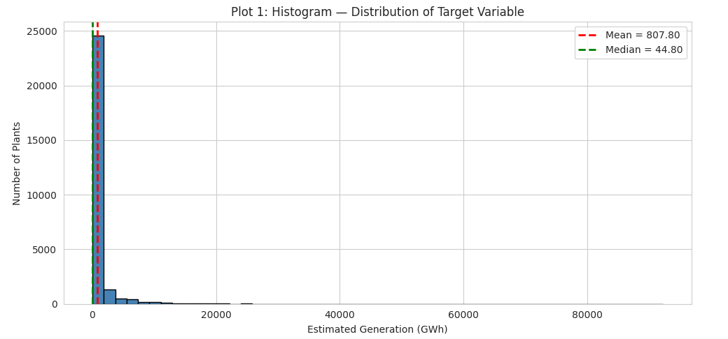
Figure 1: Distribution of Target Variable

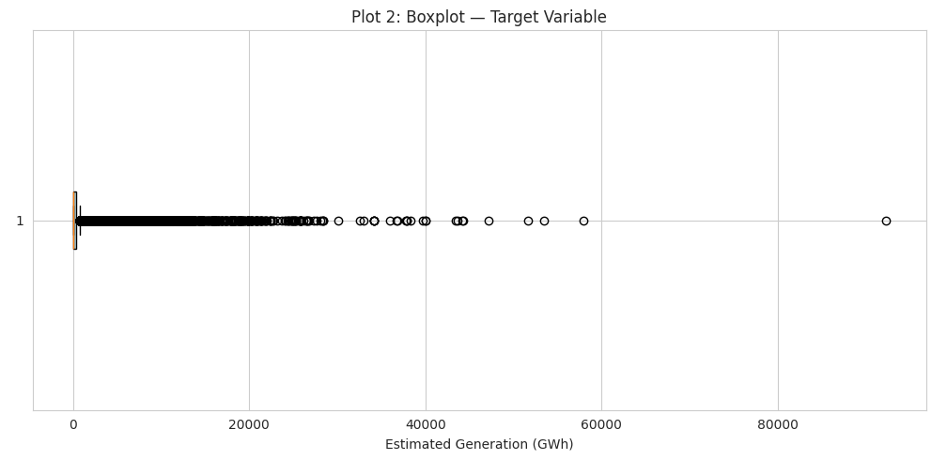
Figure 2: Target Variable Outlier Detection

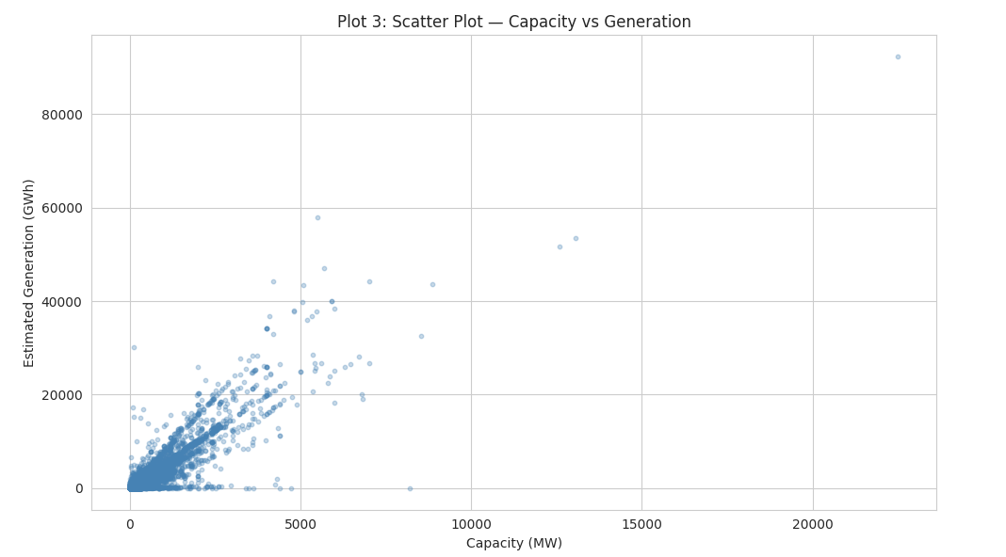
Figure 3: Capacity vs Generation

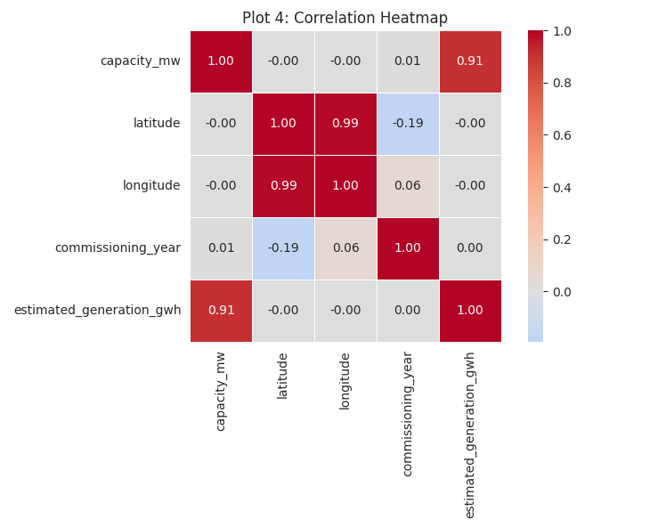
Figure 4: Correlation Heatmap

The histogram (Figure 1) revealed a strongly right-skewed distribution, where the majority of power plants generate low amounts of electricity (median = 44.80 GWh) while a small number produce significantly higher outputs, pulling the mean to 807.80 GWh. The boxplot (Figure 2) confirmed the presence of extreme outliers in the upper tail. The scatter plot (Figure 3) demonstrated a strong positive linear relationship between installed capacity (MW) and estimated generation (GWh), with a Pearson correlation coefficient of 0.9090. The correlation heatmap (Figure 4) confirmed that capacity_mw exhibits the highest correlation with the target variable, while latitude and longitude showed weak correlations. No severe multicollinearity was observed among the predictor variables. Zero duplicate rows were found in the dataset.
The EDA findings guided subsequent preprocessing decisions. Columns with excessive missing values (>85%), such as fuel2, fuel3, fuel4, and generation_gwh_2013–2016, were dropped. Rows with missing target values were removed (1,128 rows). The commissioning_year column (47.84% missing) was imputed with its median value of 2004 and converted to integer type. Outlier removal using the IQR method (Q1 = 8.10, Q3 = 293.91, IQR = 285.81, valid range: [−420.61, 722.62]) eliminated 4,544 extreme observations, leaving 22,992 clean records. Categorical variables were encoded: country_long (124 countries) via Label Encoding and fuel1 (13 fuel types) via One-Hot Encoding, yielding a final dataset of 22,992 rows × 19 columns with zero missing values. The data was split into 80% training (18,393 samples) and 20% test (4,599 samples) sets, and features were standardised using StandardScaler.

Neural Network Model for Regression
A Multi-Layer Perceptron (MLP) regression model was implemented using scikit-learn's MLPRegressor. The network architecture consisted of three hidden layers with 128, 64, and 32 neurons respectively, employing the Rectified Linear Unit (ReLU) activation function at each hidden layer. The Adam optimiser was used to minimise the mean squared error loss function. Training was configured with a maximum of 500 iterations, an adaptive learning rate starting at 0.001, and early stopping enabled with a 10% validation fraction to prevent overfitting. The model was trained on standardized features using StandardScaler.

Metric | Training Set | Test Set
MAE | 27.0376 | 26.5647
MSE | 3,572.3924 | 3,554.9845
RMSE | 59.7695 | 59.6237
R² | 0.8316 | 0.8183

Table 1: Neural Network (MLP) Performance Metrics

The neural network completed training in 112 iterations (out of a maximum of 500), with early stopping terminating the process once validation performance ceased to improve. On the training set, the model achieved an R² of 0.8316 with an RMSE of 59.7695 GWh. On the test set, it achieved an R² of 0.8183 with an RMSE of 59.6237 GWh and an MAE of 26.5647 GWh. The training loss curve (Figure 5) exhibited a rapid decline in the initial iterations followed by gradual convergence, confirming effective learning.
The close alignment between training and test performance (R² = 0.8316 vs 0.8183) indicates that the model generalised well without significant overfitting. The early stopping mechanism and adaptive learning rate contributed to stable convergence. The neural network captured non-linear relationships among features, achieving substantially better performance than the linear baseline model, though it was outperformed by the Random Forest ensemble method.
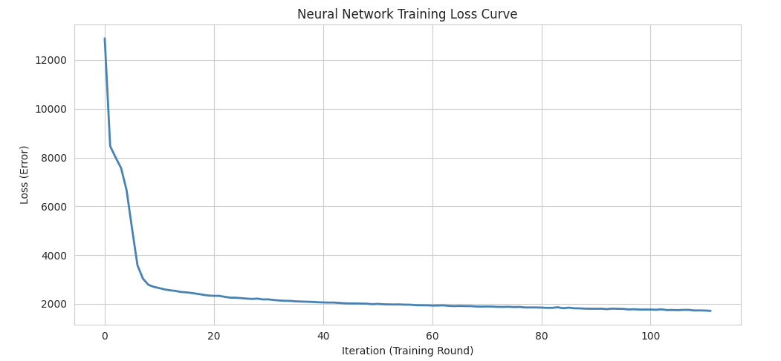
Figure 5: Neural Network Training Loss Curve

Primary Machine Learning Models (Two Classical Models)
Two classical regression models were trained and evaluated to establish baseline performance benchmarks. The first model, Linear Regression, assumes a linear relationship between the predictors and the target variable and was trained on standardised features. The second model, Random Forest Regressor, is an ensemble method that constructs 100 decision trees (with min_samples_split = 5) and averages their predictions to reduce variance. The Random Forest was trained on unscaled features, as tree-based methods are invariant to feature scaling. Both models were evaluated using Mean Absolute Error (MAE), Mean Squared Error (MSE), Root Mean Squared Error (RMSE), and the coefficient of determination (R²).
Model | MAE | MSE | RMSE | R²
Linear Regression (Train) | 82.1462 | 15,950.8037 | 126.2965 | 0.2481
Linear Regression (Test) | 77.8061 | 14,044.7577 | 118.5106 | 0.2820
Random Forest (Train) | 5.2113 | 345.4625 | 18.5866 | 0.9837
Random Forest (Test) | 10.8824 | 1,599.6278 | 39.9953 | 0.9182

Table 2: Classical Models (Performance Comparison)

The Linear Regression model achieved an R² of only 0.2820 on the test set with an RMSE of 118.5106 GWh and MAE of 77.8061 GWh, indicating that it explains only about 28% of the variance in electricity generation. In contrast, the Random Forest Regressor achieved a substantially higher test R² of 0.9182 with an RMSE of 39.9953 GWh and MAE of 10.8824 GWh, explaining approximately 92% of the target variance.
The Random Forest Regressor vastly outperformed Linear Regression across all evaluation metrics, achieving an R² nearly four times higher on the test set (0.9182 vs 0.2820). This performance gap confirms that the relationship between power plant characteristics and electricity generation is inherently non-linear. The Random Forest's ability to capture complex feature interactions and non-linear patterns makes it significantly more suitable for this regression task. However, the gap between Random Forest training R² (0.9837) and test R² (0.9182) suggests some degree of overfitting, which hyperparameter tuning may help address.

Hyperparameter Optimization with Cross-Validation
Hyperparameter optimization was performed using GridSearchCV with 5-fold cross-validation for both classical models. For Linear Regression, the model was extended to Ridge Regression (L2 regularisation), and the regularisation parameter alpha was tuned over the range [0.001, 0.01, 0.1, 1.0, 10.0, 50.0, 100.0, 500.0]. For the Random Forest Regressor, three hyperparameters were tuned: the number of estimators (n_estimators: 50, 100, 200), maximum tree depth (max_depth: 10, 20, 30), and minimum samples required to split a node (min_samples_split: 2, 5, 10). The R² score was used as the evaluation metric for selecting the best parameter configuration.
Alpha | Mean CV R² | Rank
500.0 | 0.2422 | 1
100.0 | 0.2419 | 2
50.0 | 0.2417 | 3
10.0 | 0.2392 | 4
1.0 | 0.1092 | 5
0.1 | −1.1607 | 6
0.01 | −2.1136 | 7
0.001 | −2.2597 | 8

Table 3: Ridge Regression (GridSearchCV Results)

Hyperparameter | Best Value
n_estimators | 200
max_depth | 30
min_samples_split | 2
Best CV R² | 0.9158

Table 4: Best Hyperparameters

Model | Best Hyperparameters | CV R² Score
Ridge Regression | alpha = 500.0 | 0.2422
Random Forest | n_estimators=200, max_depth=30, min_samples_split=2 | 0.9158

Table 5: Hyperparameter Tuning Summary

The GridSearchCV procedure identified the optimal configurations for both models. For Ridge Regression, the best alpha value was 500.0, yielding a CV R² of 0.2422. Notably, lower alpha values produced negative R² scores, indicating severe instability without strong regularisation. For the Random Forest, the best configuration was n_estimators = 200, max_depth = 30, and min_samples_split = 2, achieving a CV R² of 0.9158.
The Ridge Regression results reveal that the linear model requires substantial regularisation (alpha = 500.0) to avoid numerical instability, yet even with optimal tuning its performance remains limited (CV R² = 0.2422). The Random Forest achieved a dramatically higher CV R² of 0.9158, confirming its superiority for this non-linear prediction task. The 5-fold cross-validation ensured that the selected hyperparameters generalise well to unseen data rather than overfitting to the training set.

Feature Selection
Feature selection was conducted using model-based importance scores with a mean threshold criterion. For the Random Forest, the built-in feature_importances_ attribute was used, which ranks features by their contribution to reducing prediction error across all trees in the ensemble (mean threshold = 0.0556). For Ridge Regression, the absolute values of the learned coefficients were used as a proxy for feature importance (mean threshold = 12.2661). In both cases, only features with importance scores above the mean threshold were retained for the final models.
Model | Total Features | Selected Features | Features Retained
Ridge Regression | 18 | 6 | capacity_mw, fuel1_Coal, fuel1_Nuclear, fuel1_Gas, fuel1_Solar, fuel1_Oil
Random Forest | 18 | 3 | capacity_mw, country_long, fuel1_Oil

Table 6: Feature Selection Summary

The Random Forest model selected 3 out of 18 features above its mean importance threshold of 0.0556: capacity_mw (the dominant predictor), country_long, and fuel1_Oil. The Ridge Regression model selected 6 out of 18 features above its mean coefficient threshold of 12.2661: capacity_mw, fuel1_Coal, fuel1_Nuclear, fuel1_Gas, fuel1_Solar, and fuel1_Oil. Both models identified capacity_mw as the single most important predictor, consistent with the strong correlation (r = 0.9090) observed during EDA.

The feature selection process effectively reduced dimensionality for both models. The Random Forest's aggressive selection (3 features) reflects that capacity_mw dominates prediction in tree-based models, with country_long and fuel type providing additional non-linear splits. Ridge Regression retained more fuel-type features because its linear coefficients capture additive effects of different energy sources. This reduction removes noisy, low-importance features and is expected to improve generalization performance.
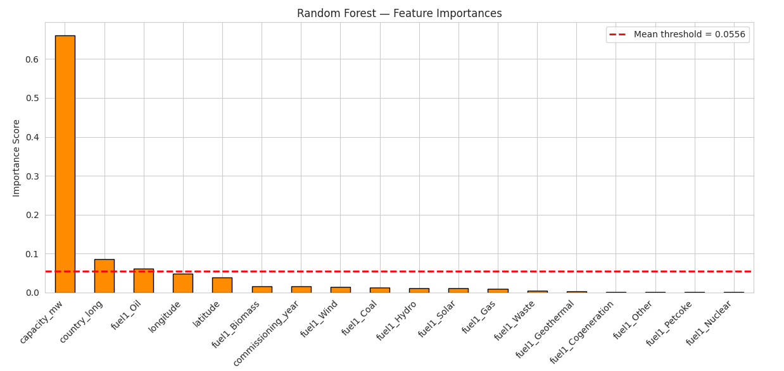
Figure 6: Random Forest Feature Importances
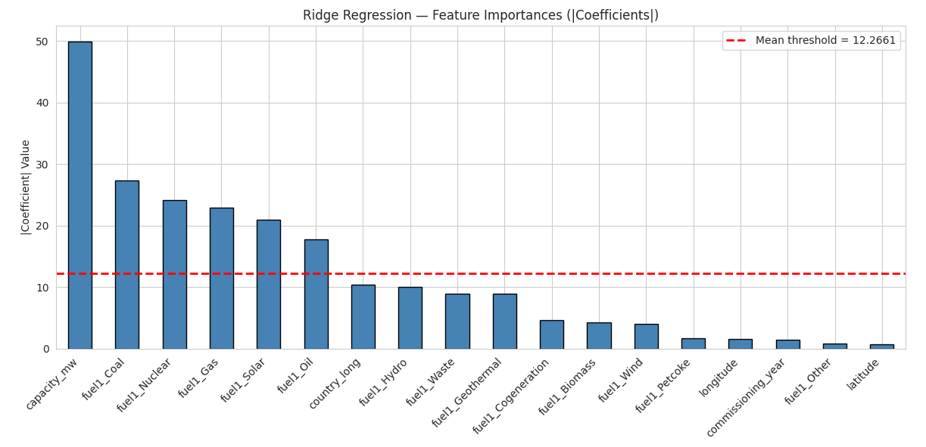
Figure 7: Ridge Regression Feature Importances

Final Models and Comparative Analysis
The final models were reconstructed using the optimal hyperparameters from Task 4 and the selected features from Task 5. The final Ridge Regression model (alpha = 500.0) was trained on 6 selected features (standardised), while the final Random Forest model (n_estimators = 200, max_depth = 30, min_samples_split = 2) was trained on 3 selected features (unscaled). Both models were evaluated on the held-out test set using MAE, RMSE, R², and 5-fold cross-validation R² scores to assess both predictive accuracy and generalization reliability.

Model | Features Used | MAE | RMSE | R² | CV R²
Ridge Regression | Selected (6) | 81.0072 | 120.5875 | 0.2567 | 0.2213
Random Forest | Selected (3) | 29.2967 | 70.0227 | 0.7494 | 0.7843

Table 7: Final Model Comparison

The final Random Forest model achieved a test R² of 0.7494 with an RMSE of 70.0227 GWh and MAE of 29.2967 GWh, with a cross-validation R² of 0.7843. The final Ridge Regression model achieved a test R² of only 0.2567 with an RMSE of 120.5875 GWh and MAE of 81.0072 GWh, with a CV R² of 0.2213. The Random Forest was confirmed as the best performing model across all metrics.
The final Random Forest model achieved the highest R² score and the lowest error metrics, confirming its superiority for this regression task. However, when comparing the final models (using selected features only) to the initial models (using all 18 features), a notable performance decrease is observed — the initial Random Forest achieved R² = 0.9182 with all features, while the final version with only 3 selected features achieved R² = 0.7494. This suggests that while feature selection reduced dimensionality, the aggressive threshold (retaining only 3 features) removed informative predictors. The Ridge Regression performance remained consistently low regardless of feature selection, confirming its fundamental limitation in modelling non-linear relationships. The cross-validation R² scores were consistent with test set performance for both models, indicating stable generalisation without overfitting.

Conclusion and Reflection

Model Performance
This study evaluated three regression approaches a Neural Network (MLP), Ridge Regression, and Random Forest Regressor for predicting annual electricity generation of global power plants. Among the initial models trained on all 18 features, the Random Forest achieved the best test R² of 0.9182, followed by the Neural Network at 0.8183, while Ridge Regression obtained only 0.2820. In the final optimised comparison using selected features, the Random Forest maintained its lead with R² = 0.7494 and RMSE = 70.0227 GWh, substantially outperforming Ridge Regression (R² = 0.2567, RMSE = 120.5875 GWh).

Impact of Methods
Cross-validation played a critical role in ensuring the reliability of hyperparameter selection, mitigating the risk of overfitting to the training data. GridSearchCV with 5-fold cross-validation identified alpha = 500.0 for Ridge and n_estimators = 200, max_depth = 30, min_samples_split = 2 for Random Forest. Feature selection using model-based importance scores reduced the feature space from 18 to 3 (Random Forest) and 6 (Ridge), removing noisy predictors. However, the aggressive feature reduction in Random Forest resulted in a performance decrease from R² = 0.9182 to 0.7494, indicating a trade-off between dimensionality reduction and predictive power.

Insights and Future Directions
A key limitation of this analysis is that the dataset relies on estimated generation values rather than actual measured outputs, which may introduce noise into the target variable. Additionally, many potentially informative columns were dropped due to excessive missing values (>85%). Future work could explore advanced imputation techniques to recover information from partially missing columns, adopt a less aggressive feature selection threshold to retain more predictive features, and experiment with gradient boosting methods (e.g., XGBoost, LightGBM) for potential performance gains.

References
[1] World Resources Institute (2018). Global Power Plant Database.
[2] United Nations (2015). Transforming Our World: The 2030 Agenda for Sustainable Development. United Nations General Assembly, A/RES/70/1.

Appendix

